**Bug fix using algo - screenshots**

Fig 1. Hello This is Pankaj, Welcome to The Desk Application

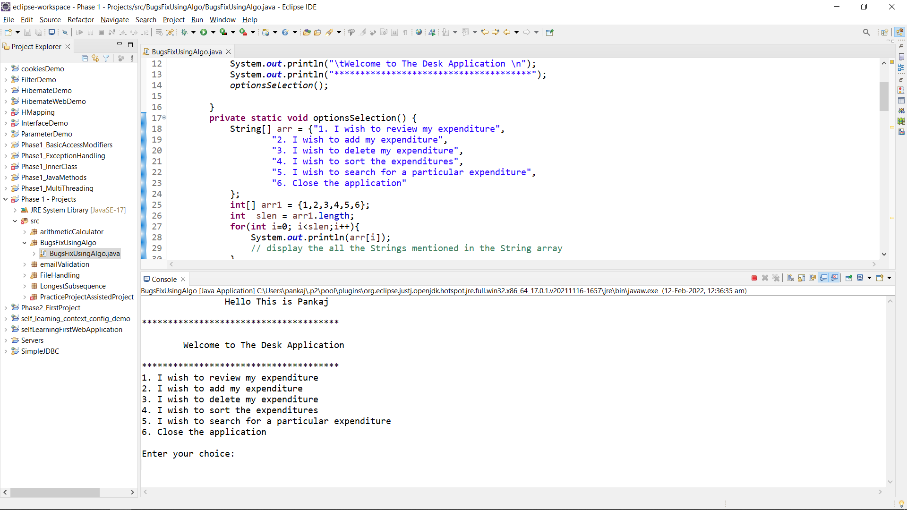

Fig 2. Choice 1 : Reviewing the expenses

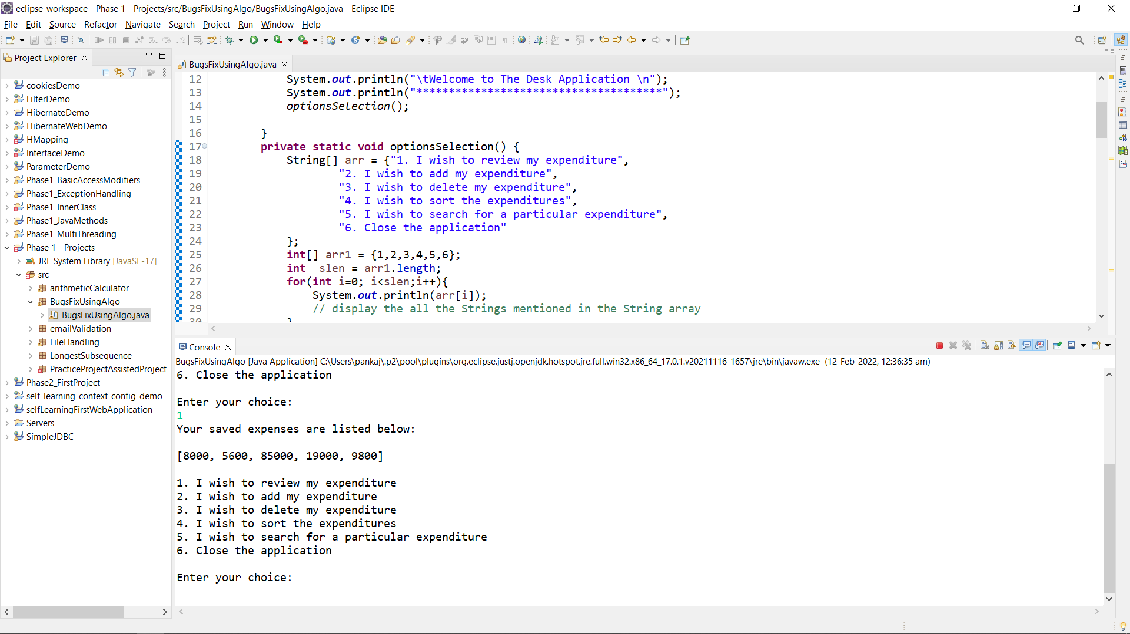

Fig 3. Choice 2 : Entering value to add to the Expenses list, Printing the Expenses list again.

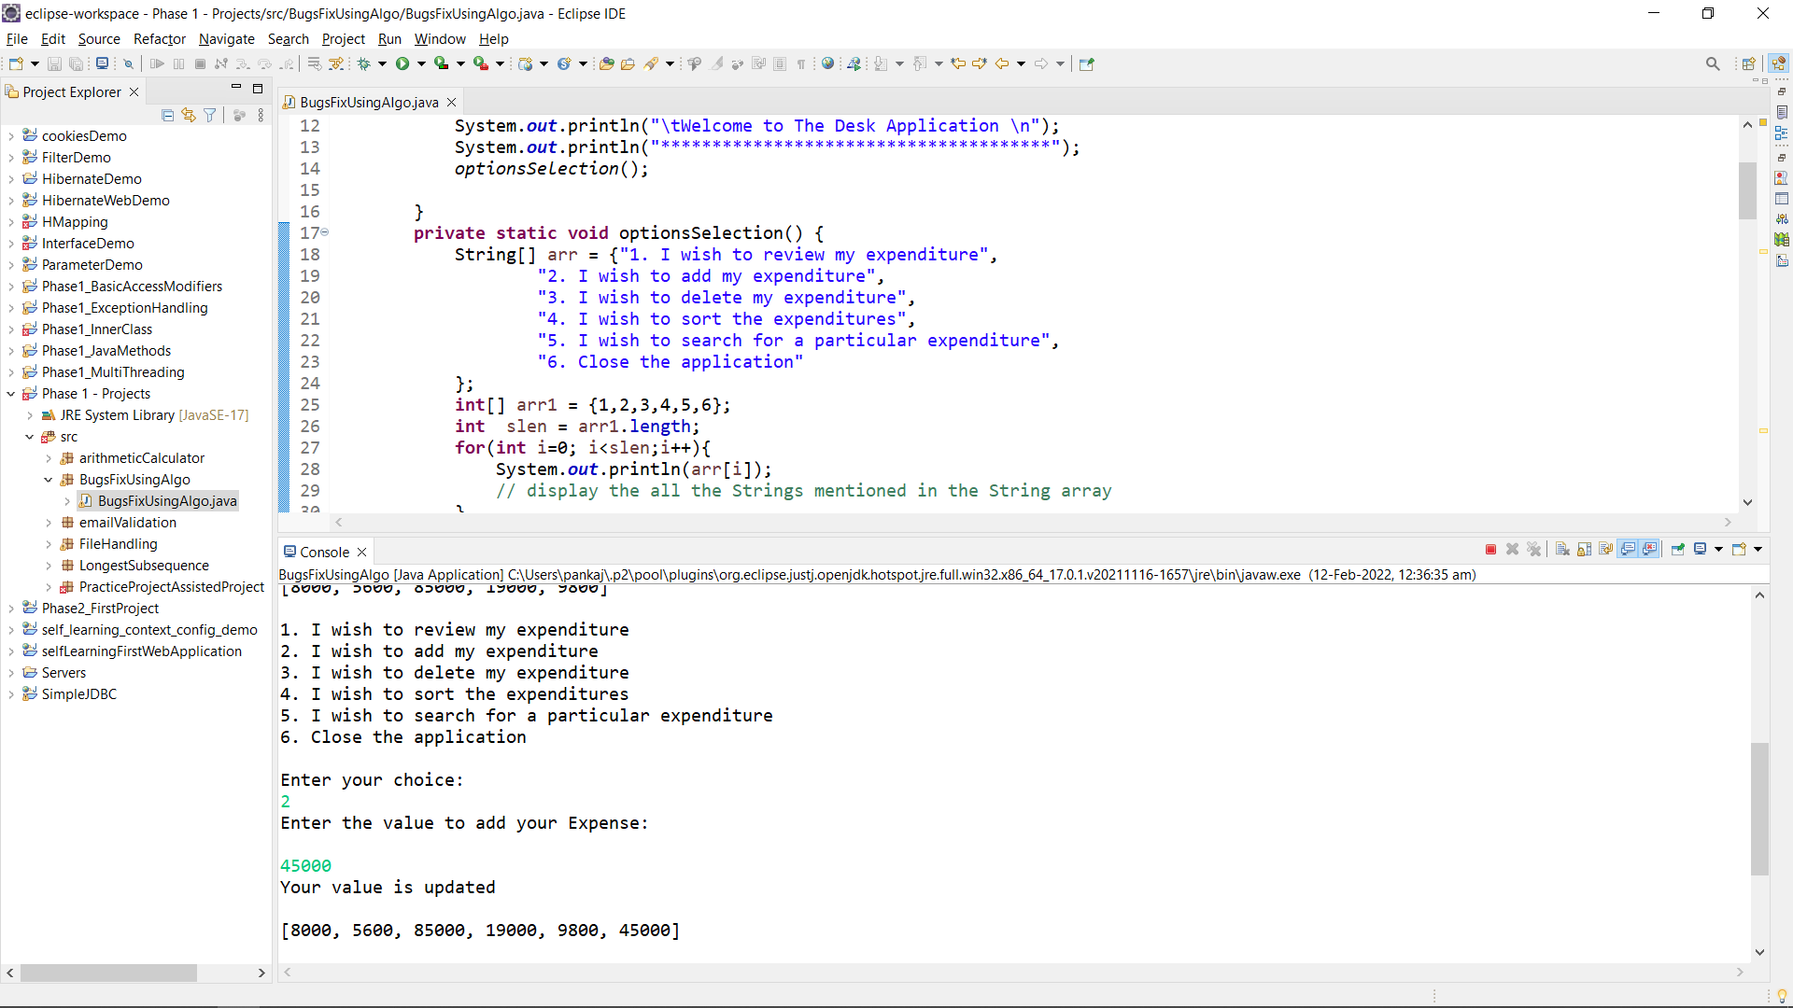

Fig 4. Choice 3 : Deleting all expenses from the list and printing again.

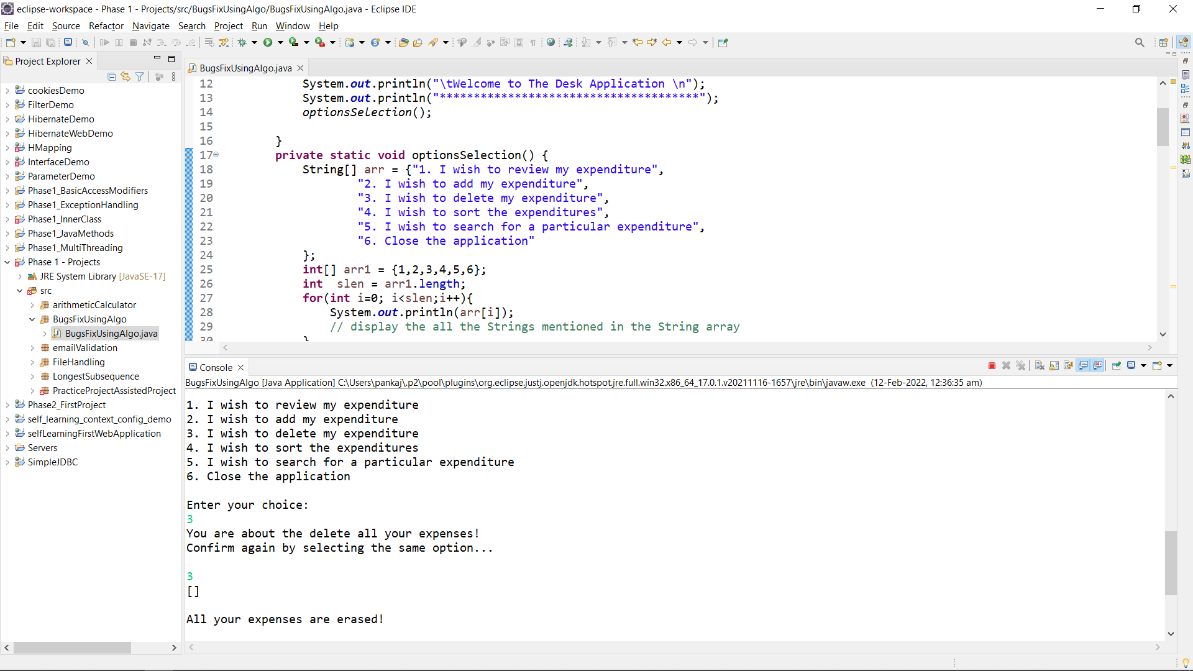

Fig 5. Choice 4 : Sorting expenses list in the ascending order

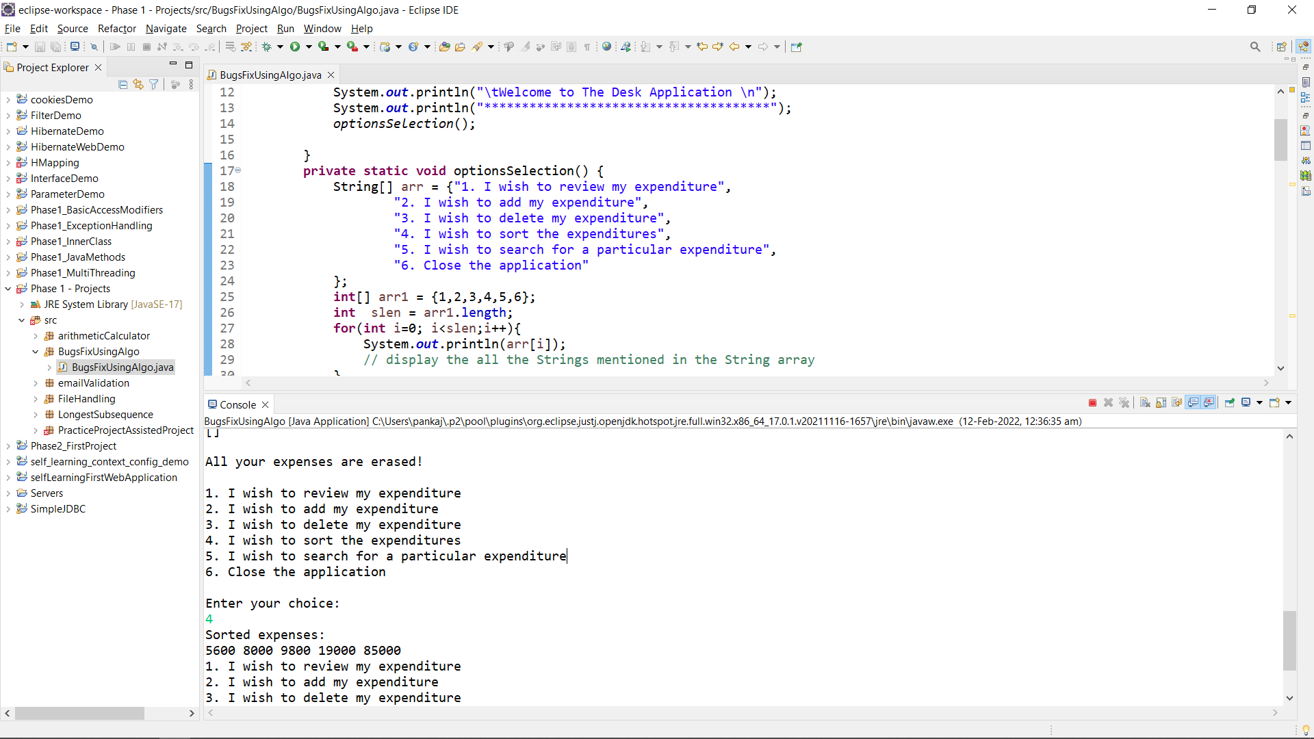

Fig 6. Choice 5 : Searching for the expenses in the list and printing the index position.

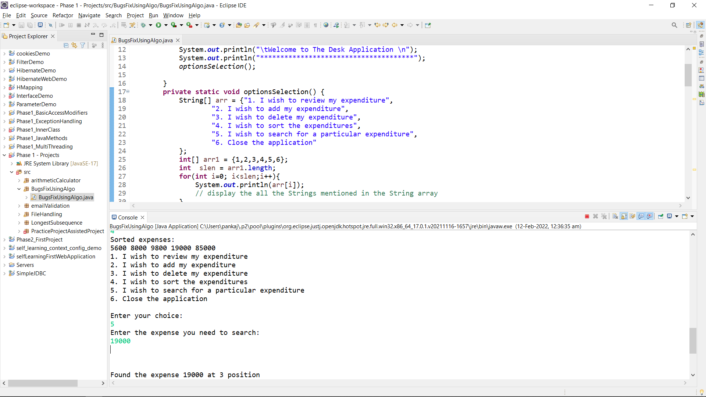

Fig 7. Choice 6 : Closing the application.

